Accessibility conformance test report
Page evaluated: 16/05/2026
Evaluator: Heshan Herath mudiyanselage

Summary of the conformance test
The conference test was carried out using WAWE accessibility evaluation tool. This test consisted of evaluating the following correct use of headings and landmarks, alternative text for images, contrast and readability between text and background, correct label association form controls and navigation with keyboard. A few images did not have alternative text. insufficient colour contrast in some text elements with background. Label elements were not associated to some form input elements.
Overall, the page is not fully compliant with the accessibility standards, although some part of the page is conducted in an acceptable way regarding accessibility. The answers to the problems mentioned would make this page more perceptible and usable to assistive to users.

Results of the conformance test

Error type | Give one or two examples (images of the relevant part of the screen can be useful) | Why is this considered to be an issue? | What should be done? | What level of conformance does it break?
Error title | You can take a screen snippet around the error shown in the page | From “Why it matters” | From “How to fix it” | From “standards and guidance”
Missing Alternative text | 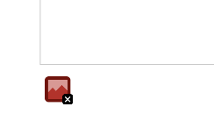 | Without alternative text, screen readers unable to understand content of the image. | Add a meaningful alt attribute to the image which explain content of the image. | 1.1.1 Non-text Content (Level A)  Icon index
Missing from label |  | Form control does not have properly associated text label, and form labels offer visible form control descriptions and bigger clickable targets for form controls. | Use <label> element to associate it with its respective form control. Add a descriptive title attribute to the form control. | 1.1.1 Non-text Content (Level A)  1.3.1 Info and Relationships (Level A)  2.4.6 Headings and Labels (Level AA)  3.3.2 Labels or Instructions (Level A)
Multiple with labels | 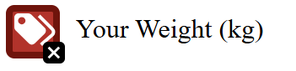 | Form control has more than one label associated with it. | If multiple form labels are necessary, use aria-labelledby. | 1.1.1 Non-text Content (Level A)  1.3.1 Info and Relationships (Level A)  2.4.6 Headings and Labels (Level AA)  3.3.2 Labels or Instructions (Level A)
Language missing or invalid |  | This is an issue because the page does not have a correctly defined language using lang attribute. | Add a valid language using the <html lang> attribute with a valid value. | 3.1.1 Language of Page (Level A)
Empty button Error | 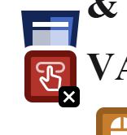 | A button has no value text. | Place text content within the <button> element. | 1.1.1 Non-text Content (Level A)  2.4.4 Link Purpose (In Context) (Level A)
Broken skip link Error | 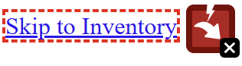 | This link is not properly functioning. | Ensure that the target for the link exists and that the link is not hidden with CSS display. | 2.1.1 Keyboard (Level A)  2.4.1 Bypass Blocks (Level A)
Low contrast error | 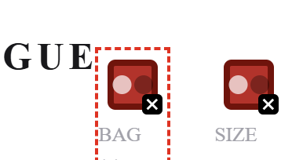 | Very low contrast between text and background colours. | Increase the contrast between the text colour and the background colour. | 1.4.3 Contrast (Minimum) (Level AA)
Missing first level heading | 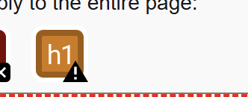 | Page doesn’t have a first level heading | Add heading using <h1> | 1.3.1 Info and Relationships (Level A)  2.4.6 Headings and Labels (Level AA)
Suspicious link text | 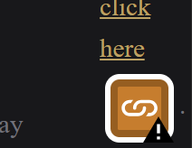 | This is an issue because the link text does not make sense when read out of context. | Reword the link text so that it is more descriptive of its destination when read out of context. | 2.4.4 Link Purpose (In Context) (Level A)
Device dependent event handler | 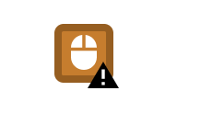 | This is an issue because the page contains an event handler that may only respond to mouse interactions. | Ensure that all critical functionality and content is accessible by using a device independent event handler. | 2.1.1 Keyboard (Level A)

References

